**Assignment -2**

**Flask Application with Database Connectivity**

|  |  |
| --- | --- |
| Assignment Date | 17 October 2022 |
| Student Name | Priyanka K |
| Student Roll Number | 715519104036 |
| Maximum Marks | 2 Marks |

**Question:**

1. Create a Flask App

2. Add the Home page, About Page

3. Add the Bootstrap

4. Add the Sign in page and App the Signup Page + database connectivity

**Solution:**

**App.py**

import sqlite3

from turtle import st

from flask import Flask, render_template, url_for, request, redirect, session, flash

from markupsafe import escape

from flask_sqlalchemy import SQLAlchemy

import ibm_db

conn = ibm_db.connect("DATABASE=bludb;HOSTNAME=764264db-9824-4b7c-82df-40d1b13897c2.bs2io90l08kqb1od8lcg.databases.appdomain.cloud;PORT=32536;SECURITY=SSL;SSLServerCertificate=DigiCertGlobalRootCA.crt;UID=gnt07311;PWD=UhulCAYn7uydIC4p",'','')

print(conn)

print("connection successful...")

app = Flask(__name__) #The variable __name__ is passed as first argument when creating an instance of the Flask object

db = SQLAlchemy(app) #object creation for DB'''

app.secret_key = "abc"

@app.route('/')

def index():

return render_template('signUp.html')

@app.route('/signUp', methods = ['POST', 'GET'])

def signUp():

if request.method == 'POST':

first_name = request.form['first_name']

last_name = request.form['last_name']

email = request.form['email']

password = request.form['password']

user_type = "Admin"

sql = "SELECT * FROM User WHERE FirstName = ?"

stmt = ibm_db.prepare(conn, sql)

ibm_db.bind_param(stmt, 1, first_name)

ibm_db.execute(stmt)

account = ibm_db.fetch_assoc(stmt)

print("signup")

if account:

print("account")

flash("You are already a member, Please login using your details")

return render_template('logIn.html', msg = "You are already a member, Please login using your details")

else:

insert_sql = "INSERT INTO User VALUES(?,?,?,?,?)"

prep_stmt = ibm_db.prepare(conn, insert_sql)

ibm_db.bind_param(prep_stmt, 1, first_name)

ibm_db.bind_param(prep_stmt, 2, last_name)

ibm_db.bind_param(prep_stmt, 3, email)

ibm_db.bind_param(prep_stmt, 4, password)

ibm_db.bind_param(prep_stmt, 5, user_type)

ibm_db.execute(prep_stmt)

print("Inserted")

flash("you are successfuly signed in")

return render_template('home.html')

else:

return render_template('logIn.html', msg = "You are already a member, Please login using your details")

@app.route('/logIn', methods = ['POST', 'GET'])

def logIn():

if request.method == 'POST':

email = request.form['email']

password = request.form['password']

sql = "SELECT * FROM User WHERE Email = ? AND Password = ?"

stmt = ibm_db.prepare(conn, sql)

ibm_db.bind_param(stmt, 1, email)

ibm_db.bind_param(stmt, 2, password)

ibm_db.execute(stmt)

account = ibm_db.fetch_assoc(stmt)

print(account)

if(account):

flash("You are successfuly logged in")

return render_template('home.html')

else:

flash("Email or password entered is incorrect")

return render_template('logIn.html', msg = "Incorrect email or password")

else:

return render_template('logIn.html', msg = "You are already a member, Please login using your details")

@app.route('/emp')

def emp():

return render_template('emp.html')

@app.route('/aboutus')

def aboutus():

return render_template('aboutUs.html')

if __name__ == "__main__":

app.run(debug=True)

**signUp.html**

<!DOCTYPE html>

<html lang="en" dir="ltr">

<head>

<meta charset="utf-8" />

<meta name="viewport" content="width=device-width, initial-scale=1" />

<title>Sign Up</title>

<!-- Bootstrap -->

<link

href="https://cdn.jsdelivr.net/npm/bootstrap@5.1.0/dist/css/bootstrap.min.css"

rel="stylesheet"

integrity="sha384-KyZXEAg3QhqLMpG8r+8fhAXLRk2vvoC2f3B09zVXn8CA5QIVfZOJ3BCsw2P0p/We"

crossorigin="anonymous"

/>

<!-- Bootstrap Scripts -->

<script

src="https://cdn.jsdelivr.net/npm/bootstrap@5.1.0/dist/js/bootstrap.bundle.min.js"

integrity="sha384-U1DAWAznBHeqEIlVSCgzq+c9gqGAJn5c/t99JyeKa9xxaYpSvHU5awsuZVVFIhvj"

crossorigin="anonymous"

></script>

<!-- Font Awesome -->

<link

rel="stylesheet"

href="https://cdnjs.cloudflare.com/ajax/libs/font-awesome/5.15.4/css/all.min.css"

integrity="sha512-1ycn6IcaQQ40/MKBW2W4Rhis/DbILU74C1vSrLJxCq57o941Ym01SwNsOMqvEBFlcgUa6xLiPY/NS5R+E6ztJQ=="

crossorigin="anonymous"

referrerpolicy="no-referrer"

/>

<!-- Google Fonts -->

<link rel="preconnect" href="https://fonts.googleapis.com" />

<link rel="preconnect" href="https://fonts.gstatic.com" crossorigin />

<link

href="https://fonts.googleapis.com/css2?family=Ubuntu:wght@300;400;500;700&display=swap"

rel="stylesheet"

/>

<!-- CSS -->

<link rel="stylesheet" href="{{ url_for('static',filename='css/signUp.css') }}" />

<script type = "text/javascript">

// alert("{% for message in messages %}{{message}}{% endfor %}");

// Form validation code will come here.

function validate()

{

if( document.myForm.first_name.value == "" ) {

alert( "Please provide your First name!" );

document.myForm.first_name.focus() ;

return false;

}

if( document.myForm.last_name.value == "" ) {

alert( "Please provide your Last name!" );

document.myForm.last_name.focus() ;

return false;

}

if( document.myForm.email.value == "" ) {

alert( "Please provide your Email!" );

document.myForm.email.focus() ;

return false;

}

if( document.myForm.password.value == "" ) {

alert( "Please provide your Password!" );

document.myForm.password.focus() ;

return false;

}

if( document.myForm.password1.value == "" ) {

alert( "This Field cannot be empty" );

document.myForm.password1.focus() ;

return false;

}

if( document.myForm.password.value != document.myForm.password1.value) {

alert( "Passwords does not match" );

return false;

}

return( true );

}

</script>

</head>

<body>

<div class="signUp">

<div class="container-well container-shadow">

<div class="container flex-container">

<div class="left-content d-flex flex-column">

<div class="image">

<img src="../static/assets/signup1.png" alt="signup-image">

</div>

</div>

<div class="form mt-4 mb-4">

<form action = "{{url_for('signUp')}}" name = "myForm" method = "POST" onsubmit = "return(validate());">

<div class="row">

<div class="col-xl-6">

<div class="mb-3">

<label class="form-label" >First Name</label>

<input type="text" class="form-control" name="first_name">

</div>

</div>

<div class="col-xl-6">

<div class="mb-3">

<label class="form-label" >Last Name</label>

<input type="text" class="form-control" name="last_name">

</div>

</div>

</div>

<div class="mb-3">

<label class="form-label" >Email</label>

<input type="email" class="form-control" name="email">

</div>

<div class="mb-3">

<label class="form-label" >Password</label>

<input type="password" class="form-control" name="password">

</div>

<div class="mb-3">

<label class="form-label" >Confirm Password</label>

<input type="password" class="form-control" name="password1">

</div>

<input type="submit" class="btn btn-blue mt-2" value="Sign Up">

</form>

<br>

<div class="d-flex flex-row">

Already have an account ?

<div>

<a class="ms-1" href="./logIn">Log In</a>

</div>

</div>

{% with messages = get_flashed_messages() %}

{% if messages %}

{% for message in messages %}

<p>{{ message }}</p>

{% endfor %}

{% endif %}

{% endwith %}

</div>

</div>

</div>

</div>

</body>

</html>

**logIn.html**

{% extends 'base.html' %}

{% block head %}

<!-- CSS -->

<link rel="stylesheet" href="{{ url_for('static',filename='css/logIn.css') }}" />

{% endblock %}

{% block body %}

<div class="logIn">

<div class="container-well container-shadow">

<div class="container flex-container">

<div class="left-content d-flex flex-column">

<div class="image">

<img src="../static/assets/login1.png" alt="login-image">

</div>

</div>

<div class="form mt-4 mb-4">

<form action = "{{url_for('logIn')}}" method = "POST">

<div class="mb-3">

<label class="form-label">Email</label>

<input type="email" class="form-control" name="email">

</div>

<div class="mb-3">

<label class="form-label">Password</label>

<input type="password" class="form-control" name="password">

</div>

<button type="submit" class="btn btn-blue mt-2">Log In</button>

</form>

<br>

<div class="d-flex flex-row">

Don't have an account ?

<div>

<a class="ms-1" href="./">Sign Up</a>

</div>

</div>

{% with messages = get_flashed_messages() %}

{% if messages %}

{% for message in messages %}

<p style="color: red;">{{ message }}</p>

{% endfor %}

{% endif %}

{% endwith %}

</div>

</div>

</div>

</div>

{% endblock %}

**home.html**

{% extends 'base.html' %}

{% block head %}

<!-- CSS -->

<link rel="stylesheet" href="{{ url_for('static',filename='css/home.css') }}" />

{% endblock %}

{% block body %}

<div class="logIn">

<div class="container-well container-shadow">

<div class="container nike buttons">

<a class="btn-hover color-1">SUPPLIER</a>

<a class="btn-hover color-1">CATEGORY</a>

<a class="btn-hover color-1">PRODUCT</a>

<a class="btn-hover color-1">SALE</a>

<a class="btn-hover color-1" href="aboutus">ABOUT US</a>

<a class="btn-hover color-1">EXIT</a>

</div>

</div>

<div class="box">

<h1 class="text-primary" style="text-align: center; font-family: fantasy;">HOME PAGE</h1>

<!-- {% with messages = get_flashed_messages() %}

{% if messages %}

{% for message in messages %}

<p>{{ message }}</p>

{% endfor %}

{% endif %}

{% endwith %} -->

<div class="row1 d-flex justify-content-between">

<div class="card border-primary mb-4">

<div class="card-body text-primary">

<h5 class="card-title text-center">TOTAL EMPLOYEE</h5>

</div>

</div>

<div class="card border-primary mb-4">

<div class="card-body text-primary">

<h5 class="card-title text-center">TOTAL SUPPLIER</h5>

</div>

</div>

<div class="card border-primary mb-4">

<div class="card-body text-primary">

<h5 class="card-title text-center">TOTAL CATEGORY</h5>

</div>

</div>

</div>

<div class="row1 d-flex justify-content-around">

<div class="card border-primary mb-4">

<div class="card-body text-primary">

<h5 class="card-title text-center" >TOTAL PRODUCT</h5>

</div>

</div>

<div class="card border-primary mb-4">

<div class="card-body text-primary">

<h5 class="card-title text-center">TOTAL SALES</h5>

</div>

</div>

</div>

<!-- <div class="row1 d-flex justify-content-center">

</div> -->

</div>

</div>

{% endblock %}

**emp.html**

{% extends 'base.html' %}

{% block head %}

<link rel="stylesheet" href="{{ url_for('static',filename='css/emp.css') }}" />

{% endblock %}

{% block body %}

<form id="ft-form" method="POST">

<fieldset>

<legend style="text-align: center; font-size: 2rem;">DETAILS</legend>

<div class="two-cols">

<label>

First name *

<input type="text" name="First name" required>

</label>

<label>

Last name *

<input type="text" name="Last name" required>

</label>

</div>

<div class="two-cols">

<label>

Employee ID

<input type="text" name="empid">

</label>

<label>

Date of birth

<input type="date" name="Date of birth">

</label>

</div>

<label>

Address

<input type="text" name="Address">

</label>

<div class="two-cols">

<label>

ZIP Code

<input type="text" name="ZIP">

</label>

<label>

City

<input type="text" name="City">

</label>

</div>

<div class="two-cols">

<label>

Phone *

<input type="tel" name="Phone" required>

</label>

<label>

Email address *

<input type="email" name="Email" required>

</label>

</div>

</fieldset>

<div class="btns">

<input type="text" name="_gotcha" value="" style="display:none;">

<input type="submit" value="Submit application">

</div>

</form>

{% endblock %}

**base.html**

<!DOCTYPE html>

<html lang="en" dir="ltr">

<head>

<meta charset="utf-8" />

<meta name="viewport" content="width=device-width, initial-scale=1" />

<title>Log In</title>

<!-- Bootstrap -->

<link

href="https://cdn.jsdelivr.net/npm/bootstrap@5.1.0/dist/css/bootstrap.min.css"

rel="stylesheet"

integrity="sha384-KyZXEAg3QhqLMpG8r+8fhAXLRk2vvoC2f3B09zVXn8CA5QIVfZOJ3BCsw2P0p/We"

crossorigin="anonymous"

/>

<!-- Bootstrap Scripts -->

<script

src="https://cdn.jsdelivr.net/npm/bootstrap@5.1.0/dist/js/bootstrap.bundle.min.js"

integrity="sha384-U1DAWAznBHeqEIlVSCgzq+c9gqGAJn5c/t99JyeKa9xxaYpSvHU5awsuZVVFIhvj"

crossorigin="anonymous"

></script>

<!-- Font Awesome -->

<link

rel="stylesheet"

href="https://cdnjs.cloudflare.com/ajax/libs/font-awesome/5.15.4/css/all.min.css"

integrity="sha512-1ycn6IcaQQ40/MKBW2W4Rhis/DbILU74C1vSrLJxCq57o941Ym01SwNsOMqvEBFlcgUa6xLiPY/NS5R+E6ztJQ=="

crossorigin="anonymous"

referrerpolicy="no-referrer"

/>

<!-- Google Fonts -->

<link rel="preconnect" href="https://fonts.googleapis.com" />

<link rel="preconnect" href="https://fonts.gstatic.com" crossorigin />

<link

href="https://fonts.googleapis.com/css2?family=Ubuntu:wght@300;400;500;700&display=swap"

rel="stylesheet"

/>

{% block head %}{% endblock %}

</head>

<body>

{% block body %}{% endblock %}

</body>

</html>

**aboutUs.html**

{% extends 'base.html' %}

{% block head %}

<!-- CSS -->

<link rel="stylesheet" href="{{ url_for('static',filename='css/aboutUs.css') }}" />

{% endblock %}

{% block body %}

<div class="outercont">

<div class="cont">

<div class="textcont">

<h2>Inventory Management System</h2>

<p>Our Inventory Management Software is designed to streamline your processes and increase profits.</p>

</div>

<div class="othercont">

<div class="leftcont">

<div><i class="fa fa-check" style="font-size:24px;color:green"></i> Min/Max Stock Levels</div>

<div><i class="fa fa-check" style="font-size:24px;color:green"></i> Multiple Stores</div>

<div><i class="fa fa-check" style="font-size:24px;color:green"></i> Inventory Valuation</div>

<div><i class="fa fa-check" style="font-size:24px;color:green"></i> Inventory Rejected/Dead Stock</div>

</div>

<div class="rightcont">

<div><i class="fa fa-check" style="font-size:24px;color:green"></i> Negative Stock Restriction </div>

<div><i class="fa fa-check" style="font-size:24px;color:green"></i> Barcode Tracking</div>

<div><i class="fa fa-check" style="font-size:24px;color:green"></i> Auto Stock Adjustment</div>

<div><i class="fa fa-check" style="font-size:24px;color:green"></i> Physical Stock Reconciliation</div>

</div>

</div>

</div>

<div class="cont">

<div class="textcont">

<h2>Sales & Purchase</h2>

<p>Manage sales and purchase orders, create invoices, and E-way bills from a single order management system.</p>

</div>

<div class="othercont">

<div class="leftcont">

<div><i class="fa fa-check" style="font-size:24px;color:green"></i> Order Confirmation</div>

<div><i class="fa fa-check" style="font-size:24px;color:green"></i> Purchase Order</div>

<div><i class="fa fa-check" style="font-size:24px;color:green"></i> Inward/GRN Register</div>

<div><i class="fa fa-check" style="font-size:24px;color:green"></i> E-Way Bill</div>

</div>

<div class="rightcont">

<div><i class="fa fa-check" style="font-size:24px;color:green"></i> Sales Order </div>

<div><i class="fa fa-check" style="font-size:24px;color:green"></i> GST Invoices</div>

<div><i class="fa fa-check" style="font-size:24px;color:green"></i> Credit/Debit Note</div>

<div><i class="fa fa-check" style="font-size:24px;color:green"></i> Service Transactions </div>

</div>

</div>

</div>

<div class="cont">

<div class="textcont">

<h2>Production</h2>

<p>Plan and track the production process using our Inventory Management System to increase efficiency by eliminating downtime and cutting down cost.</p>

</div>

<div class="othercont">

<div class="leftcont">

<div><i class="fa fa-check" style="font-size:24px;color:green"></i> Multi-Level Bill of Materials (BOM)</div>

<div><i class="fa fa-check" style="font-size:24px;color:green"></i> BOM Costing</div>

<div><i class="fa fa-check" style="font-size:24px;color:green"></i> Work Order</div>

<div><i class="fa fa-check" style="font-size:24px;color:green"></i> Production Order </div>

</div>

<div class="rightcont">

<div><i class="fa fa-check" style="font-size:24px;color:green"></i> Outsourcing / Sub-Contract</div>

<div><i class="fa fa-check" style="font-size:24px;color:green"></i> Finished Goods Testing</div>

<div><i class="fa fa-check" style="font-size:24px;color:green"></i> Line Rejection Tracking</div>

<div><i class="fa fa-check" style="font-size:24px;color:green"></i> Process Routing </div>

</div>

</div>

</div>

</div>

{% endblock %}

**signUp.css**

* {

margin: 0;

padding: 0;

box-sizing: border-box;

font-family: 'Ubuntu', sans-serif;

}

:root{

--primary: #34ACE0;

--primary-shadow: rgba(52, 172, 224 , 0.25);

}

body {

background-color: var(--primary-shadow);

display: flex;

flex-direction: column;

min-height: 100vh;

}

.image{

padding-top: 8%;

}

.logo {

position: relative;

cursor: pointer;

display: flex;

align-items: center;

}

.logo h1 {

color: var(--primary);

margin: 0;

display: inline-block;

font-size: 1.75rem;

}

img {

width: 100%;

height: 100%;

}

.logo div {

background-color: var(--primary);

margin-right: 5px;

border-radius: 5px;

height: 40px;

width: 40px;

display: flex;

justify-content: center;

align-items: center;

}

.logo span {

color: white;

font-size: 2.75rem;

transform: rotate(-15deg);

position: relative;

top: -3px;

left: -1.5px;

}

.signUp {

display: flex;

justify-content: center;

align-items: center;

min-height: 100vh;

margin-top: min(20px, 25px);

margin-bottom: min(20px, 25px);

}

.flex-container {

display: flex;

flex-direction: row;

}

.container-well {

display: flex;

justify-content: center;

align-items: center;

background-color: white;

height: 550px;

width: 900px;

border-radius: 0 35px 0 35px;

}

.container-shadow {

box-shadow: 0 0 100px 0 var(--primary);

}

.left-content {

display: flex;

justify-content: center;

align-items: center;

width: 50%;

height: 100%;

}

.form {

align-items: center;

width: 50%;

padding-left: 20px;

padding-right: 20px;

}

.form a {

text-decoration: none;

color: var(--primary);

transition: 0.5s;

}

.form a:hover {

color: black;

}

.btn-white {

color: var(--primary);

box-shadow: 0 0 20px 0 var(--primary-shadow);

transition: 1s;

}

.btn-blue {

background-color: var(--primary);

color: white;

box-shadow: 0 0 20px 0 var(--primary-shadow);

transition: 1s;

}

@media (max-width: 1199px) {

.container-well {

width: 700px;

height: 600px;

}

}

@media (max-width: 767px) {

.container-well {

border-radius: 20px;

}

.image {

display: none;

}

.left-content {

width: 100%;

}

.form {

width: 100%

}

.container-well {

width: 90%;

height: 90%;

}

.flex-container {

flex-direction: column;

}

}

@media (max-width: 330px){

.form div {

flex-direction: column !important;

}

}

**logIn.css**

* {

margin: 0;

padding: 0;

box-sizing: border-box;

font-family: 'Ubuntu', sans-serif;

}

:root{

--primary: #34ACE0;

--primary-shadow: rgba(52, 172, 224 , 0.25);

}

body {

background-color: var(--primary-shadow);

display: flex;

flex-direction: column;

min-height: 100vh;

}

.logo {

position: relative;

cursor: pointer;

display: flex;

align-items: center;

}

img{

width: 100%;

height: 100%;

}

.logo h1 {

color: var(--primary);

margin: 0;

display: inline-block;

font-size: 1.75rem;

}

.logo div {

background-color: var(--primary);

margin-right: 5px;

border-radius: 5px;

height: 40px;

width: 40px;

display: flex;

justify-content: center;

align-items: center;

}

.logo span {

color: white;

font-size: 2.75rem;

transform: rotate(-15deg);

position: relative;

top: -3px;

left: -1.5px;

}

.logIn {

display: flex;

justify-content: center;

align-items: center;

min-height: 100vh;

margin-top: min(20px, 25px);

margin-bottom: min(20px, 25px);

}

.flex-container {

display: flex;

flex-direction: row;

}

.container-well {

display: flex;

justify-content: center;

align-items: center;

background-color: white;

height: 550px;

width: 900px;

border-radius: 0 35px 0 35px;

}

.container-shadow {

box-shadow: 0 0 100px 0 var(--primary);

}

.left-content {

display: flex;

justify-content: center;

align-items: center;

width: 50%;

height: 100%;

}

.form {

display: flex;

flex-direction: column;

justify-content: center;

width: 50%;

padding-left: 20px;

padding-right: 20px;

}

.form a {

text-decoration: none;

color: var(--primary);

transition: 0.5s;

}

.form a:hover {

color: black;

}

.btn-white {

color: var(--primary);

box-shadow: 0 0 20px 0 var(--primary-shadow);

transition: 1s;

}

.btn-blue {

background-color: var(--primary);

color: white;

box-shadow: 0 0 20px 0 var(--primary-shadow);

transition: 1s;

}

@media (max-width: 1199px) {

.container-well {

width: 700px;

height: 600px;

}

}

@media (max-width: 767px) {

.container-well {

border-radius: 20px;

}

.image {

display: none;

}

.left-content {

width: 100%;

}

.form {

width: 100%

}

.container-well {

width: 90%;

height: 90%;

}

.flex-container {

flex-direction: column;

}

}

@media (max-width: 330px){

.form div {

flex-direction: column !important;

}

}

**home.css**

* {

margin: 0;

padding: 0;

box-sizing: border-box;

font-family: 'Lobster', sans-serif;

-webkit-box-sizing: border-box;

-moz-box-sizing: border-box;

}

.buttons {

/* margin: 10%; */

text-align: center;

/* font-size: large; */

font-size: 15px;

}

.btn-hover {

/* width: 200px; */

font-size: 16px;

font-weight: 600;

color: #fff;

cursor: pointer;

/* margin: 20px; */

/* height: 55px; */

text-align:center;

border: none;

background-size: 300% 100%;

border-radius: 50px;

-moz-transition: all .4s ease-in-out;

-o-transition: all .4s ease-in-out;

-webkit-transition: all .4s ease-in-out;

transition: all .4s ease-in-out;

}

.btn-hover:hover {

background-position: 100% 0;

-moz-transition: all .4s ease-in-out;

-o-transition: all .4s ease-in-out;

-webkit-transition: all .4s ease-in-out;

transition: all .4s ease-in-out;

}

.btn-hover:focus {

outline: none;

}

.btn-hover.color-1 {

background-image: linear-gradient(to right, #25aae1, #40e495, #30dd8a, #2bb673);

box-shadow: 0 4px 15px 0 rgba(49, 196, 190, 0.75);

}

.btn-hover.color-2 {

background-image: linear-gradient(to right, #f5ce62, #e43603, #fa7199, #e85a19);

box-shadow: 0 4px 15px 0 rgba(229, 66, 10, 0.75);

}

.btn-hover.color-3 {

background-image: linear-gradient(to right, #667eea, #764ba2, #6B8DD6, #8E37D7);

box-shadow: 0 4px 15px 0 rgba(116, 79, 168, 0.75);

}

.btn-hover.color-4 {

background-image: linear-gradient(to right, #fc6076, #ff9a44, #ef9d43, #e75516);

box-shadow: 0 4px 15px 0 rgba(252, 104, 110, 0.75);

}

.btn-hover.color-5 {

background-image: linear-gradient(to right, #0ba360, #3cba92, #30dd8a, #2bb673);

box-shadow: 0 4px 15px 0 rgba(23, 168, 108, 0.75);

}

.btn-hover.color-6 {

background-image: linear-gradient(to right, #009245, #FCEE21, #00A8C5, #D9E021);

box-shadow: 0 4px 15px 0 rgba(83, 176, 57, 0.75);

}

.btn-hover.color-7 {

background-image: linear-gradient(to right, #6253e1, #852D91, #A3A1FF, #F24645);

box-shadow: 0 4px 15px 0 rgba(126, 52, 161, 0.75);

}

.btn-hover.color-8 {

background-image: linear-gradient(to right, #29323c, #485563, #2b5876, #4e4376);

box-shadow: 0 4px 15px 0 rgba(45, 54, 65, 0.75);

}

.btn-hover.color-9 {

background-image: linear-gradient(to right, #25aae1, #4481eb, #04befe, #3f86ed);

box-shadow: 0 4px 15px 0 rgba(65, 132, 234, 0.75);

}

.btn-hover.color-10 {

background-image: linear-gradient(to right, #ed6ea0, #ec8c69, #f7186a , #FBB03B);

box-shadow: 0 4px 15px 0 rgba(236, 116, 149, 0.75);

}

.btn-hover.color-11 {

background-image: linear-gradient(to right, #eb3941, #f15e64, #e14e53, #e2373f);

box-shadow: 0 5px 15px rgba(242, 97, 103, .4);

}

.contenedor {

height: 100%;

padding: 5% 0;

}

h1 {

color: #FCFBFA;

}

.container_foto {

background-color: rgba(57, 62, 93, 0.7);

padding: 0;

overflow: hidden;

max-width: 350px;

margin: 5px;

}

.container_foto article {

padding: 10%;

position: absolute;

bottom: 0;

z-index: 1;

-webkit-transition: all 0.5s ease;

-moz-transition: all 0.5s ease;

-o-transition: all 0.5s ease;

-ms-transition: all 0.5s ease;

transition: all 0.5s ease;

}

.container_foto h2 {

color: #fff;

font-weight: 800;

font-size: 25px;

border-bottom: #fff solid 1px;

}

.container_foto h4 {

font-weight: 300;

color: #fff;

font-size: 16px;

}

.container_foto img {

width: 100%;

top: 0;

left: 0;

opacity: 0.4;

-webkit-transition: all 4s ease;

-moz-transition: all 4s ease;

-o-transition: all 4s ease;

-ms-transition: all 4s ease;

transition: all 4s ease;

}

.ver_mas {

background-color: #FEB66C;

position: absolute;

width: 100%;

height: 70px;

bottom: 0;

z-index: 1;

opacity: 0;

transform: translate(0px, 70px);

-webkit-transform: translate(0px, 70px);

-moz-transform: translate(0px, 70px);

-o-transform: translate(0px, 70px);

-ms-transform: translate(0px, 70px);

-webkit-transition: all 0.2s ease-in-out;

-moz-transition: all 0.2s ease-in-out;

-o-transition: all 0.2s ease-in-out;

-ms-transition: all 0.2s ease-in-out;

transition: all 0.2s ease-in-out;

}

.ver_mas span {

font-size: 40px;

color: #fff;

position: relative;

margin: 0 auto;

width: 100%;

top: 13px;

}

/*hovers*/

.container_foto:hover {

cursor: pointer;

}

.container_foto:hover img {

opacity: 0.1;

transform: scale(1.5);

}

.container_foto:hover article {

transform: translate(2px, -69px);

-webkit-transform: translate(2px, -69px);

-moz-transform: translate(2px, -69px);

-o-transform: translate(2px, -69px);

-ms-transform: translate(2px, -69px);

}

.container_foto:hover .ver_mas {

transform: translate(0px, 0px);

-webkit-transform: translate(0px, 0px);

-moz-transform: translate(0px, 0px);

-o-transform: translate(0px, 0px);

-ms-transform: translate(0px, 0px);

opacity: 1;

}

:root{

--primary: #34ACE0;

--primary-shadow: rgba(52, 172, 224 , 0.25);

}

.row1{

width: 75%;

margin-top: 3rem;

margin-bottom: 3rem;

}

body {

background-color: var(--primary-shadow);

display: flex;

flex-direction: column;

min-height: 100vh;

background-image: url("../assets/b2.jpeg");

background-repeat: no-repeat;

background-position: center;

background-size: cover;

}

img{

width: 100%;

height: 100%;

}

.logIn {

display: flex;

/* justify-content: center; */

align-items: center;

min-height: 95vh;

margin-top: min(20px, 25px);

margin-bottom: min(20px, 25px);

}

.flex-container {

display: flex;

flex-direction: row;

}

.box{

display: flex;

flex-direction: column;

width: 100%;

justify-content: space-between;

align-items: center;

}

/* .card

{

width: 200px;

height:200px;

background-color: #8186a3;

} *

.card {

width: 300px;

height:300px;

background-color:#C2F7EB;

transition: transform 0.2s ease;

box-shadow: 0 4px 6px 0 rgba(22, 22, 26, 0.18);

border-radius: 0;

border: 0;

margin-bottom: 1.5em;

border-radius: 2rem;

font-style: italic;

}

.card:hover {

transform: scale(1.1);

}

/* .container-well {

display: flex;

justify-content: center; */

/* align-items: center;

background-color: white;

height: 550px;

width: 900px;

border-radius: 0 35px 0 35px;

} */

button{

height: 100px;

}

a {

padding-top: 40px;

padding-bottom: 40px;

text-decoration: none;

}

.nike

{

display: flex;

flex-direction: column;

justify-content: space-around;

/* justify-content: flex-start; */

width: 300px;

height: 95vh;

}

/* .container-shadow {

box-shadow: 0 0 100px 0 var(--primary);

} */

.left-content {

display: flex;

justify-content: center;

align-items: center;

width: 50%;

height: 100%;

}

.btn-white {

color: var(--primary);

box-shadow: 0 0 20px 0 var(--primary-shadow);

transition: 1s;

}

.btn-blue {

background-color: var(--primary);

color: white;

box-shadow: 0 0 20px 0 var(--primary-shadow);

transition: 1s;

}

@media (max-width: 1199px) {

.container-well {

width: 700px;

height: 600px;

}

}

@media (max-width: 767px) {

.container-well {

border-radius: 20px;

}

.image {

display: none;

}

.left-content {

width: 100%;

}

.form {

width: 100%

}

.container-well {

width: 90%;

height: 90%;

}

.flex-container {

flex-direction: column;

}

}

@media (max-width: 330px){

.form div {

flex-direction: column !important;

}

}

**emp.css**

#ft-form {

font-family: inherit;

font-size: 100%;

line-height: 1.15

}

#ft-form *,

#ft-form ::after,

#ft-form ::before {

box-sizing: border-box

}

#ft-form input,

#ft-form select,

#ft-form textarea {

font-family: inherit;

font-size: 100%;

line-height: 1.15;

margin: 0

}

#ft-form select {

text-transform: none

}

#ft-form [type=submit] {

-webkit-appearance: button

}

#ft-form legend {

padding: 0

}

#ft-form h2,

#ft-form p {

margin: 0

}

#ft-form fieldset {

margin: 0;

padding: 0

}

#ft-form html {

font-family: ui-sans-serif,system-ui,-apple-system,BlinkMacSystemFont,"Segoe UI",Roboto,"Helvetica Neue",Arial,"Noto Sans",sans-serif,"Apple Color Emoji","Segoe UI Emoji","Segoe UI Symbol","Noto Color Emoji";

/* line-height: 1.5 */

}

body {

background-image: url("../assets/b2.jpeg");

background-repeat: no-repeat;

background-position: center;

background-size: cover;

/* height: 100vh; */

}

#ft-form body {

font-family: inherit;

line-height: inherit;

}

#ft-form *,

#ft-form ::after,

#ft-form ::before {

box-sizing: border-box;

border-width: 0;

border-style: solid;

border-color: #e5e7eb

}

#ft-form textarea {

resize: vertical

}

#ft-form input::-moz-placeholder,

#ft-form textarea::-moz-placeholder {

color: #9ca3af

}

#ft-form input:-ms-input-placeholder,

#ft-form textarea:-ms-input-placeholder {

color: #9ca3af

}

#ft-form input::placeholder,

#ft-form textarea::placeholder {

color: #9ca3af

}

#ft-form h2 {

font-size: inherit;

font-weight: inherit

}

#ft-form input,

#ft-form select,

#ft-form textarea {

padding: 0;

line-height: inherit;

color: inherit

}

#ft-form [type=date],

#ft-form [type=email],

#ft-form [type=tel],

#ft-form [type=text],

#ft-form select,

#ft-form textarea {

-webkit-appearance: none;

-moz-appearance: none;

appearance: none;

background-color: #fff;

border-color: #6b7280;

border-width: 1px;

border-radius: 0;

padding-top: .5rem;

padding-right: .75rem;

padding-bottom: .5rem;

padding-left: .75rem;

font-size: 1rem;

line-height: 1.5rem

}

#ft-form [type=date]:focus,

#ft-form [type=email]:focus,

#ft-form [type=tel]:focus,

#ft-form [type=text]:focus,

#ft-form select:focus,

#ft-form textarea:focus {

outline: 2px solid transparent;

outline-offset: 2px;

box-shadow: 0 0 0 0 #fff, 0 0 0 3px rgba(199,210,254,.5), 0 0 #0000;

border-color: #2563eb

}

#ft-form input::-moz-placeholder,

#ft-form textarea::-moz-placeholder {

color: #6b7280;

opacity: 1

}

#ft-form input:-ms-input-placeholder,

#ft-form textarea:-ms-input-placeholder {

color: #6b7280;

opacity: 1

}

#ft-form input::placeholder,

#ft-form textarea::placeholder {

color: #6b7280;

opacity: 1

}

#ft-form select {

background-image: url("data:image/svg+xml,%3csvg xmlns='http://www.w3.org/2000/svg' fill='none' viewBox='0 0 20 20'%3e%3cpath stroke='%236b7280' stroke-linecap='round' stroke-linejoin='round' stroke-width='1.5' d='M6 8l4 4 4-4'/%3e%3c/svg%3e");

background-position: right .5rem center;

background-repeat: no-repeat;

background-size: 1.5em 1.5em;

padding-right: 2.5rem;

}

#ft-form fieldset {

font-size: 100%;

margin: 3rem;

/* margin-bottom: 1.5rem */

}

#ft-form fieldset:first-child {

margin-top: 0

}

#ft-form fieldset > * {

display: block;

margin-bottom: 1.5rem

}

#ft-form fieldset > :last-child {

margin-bottom: 0

}

#ft-form fieldset > .two-cols > * {

display: block;

margin-bottom: 1.5rem

}

#ft-form fieldset > .two-cols > :last-child {

margin-bottom: 0

}

@media only screen and (min-width:640px) {

#ft-form fieldset > .two-cols {

display: flex;

align-items: flex-end

}

#ft-form fieldset > .two-cols > * {

display: block;

margin-right: 1.5rem;

margin-top: 0;

margin-bottom: 0;

flex: 1

}

#ft-form fieldset > .two-cols > :last-child {

margin-right: 0

}

}

#ft-form fieldset div > label {

display: inline-flex;

align-items: flex-start;

margin-top: .5rem;

width: 100%

}

#ft-form fieldset div > label:last-child {

margin: .5rem 0 0 0

}

#ft-form fieldset div.inline {

padding: .55rem 0 0;

width: 100%

}

#ft-form fieldset div.inline > label {

width: auto;

margin-right: .5rem

}

#ft-form fieldset div.inline > label:last-child {

margin-right: 0

}

#ft-form fieldset > .two-cols div.inline {

padding: .55rem 0

}

#ft-form fieldset > legend {

font-weight: 700;

font-size: 120%;

margin-bottom: 1rem

}

#ft-form fieldset > p {

margin: 0

}

#ft-form [multiple],

#ft-form [type=date],

#ft-form [type=datetime-local],

#ft-form [type=email],

#ft-form [type=file],

#ft-form [type=month],

#ft-form [type=number],

#ft-form [type=password],

#ft-form [type=search],

#ft-form [type=tel],

#ft-form [type=text],

#ft-form [type=time],

#ft-form [type=url],

#ft-form [type=week],

#ft-form select,

#ft-form textarea {

border-radius: .375rem;

margin-top: .25rem;

box-shadow: 0 0 #0000,0 0 #0000,0 1px 2px 0 rgba(0,0,0,.05);

border-color: #bbb;

width: 100%

}

#ft-form [multiple] select,

#ft-form [type=date] select,

#ft-form [type=datetime-local] select,

#ft-form [type=email] select,

#ft-form [type=file] select,

#ft-form [type=month] select,

#ft-form [type=number] select,

#ft-form [type=password] select,

#ft-form [type=search] select,

#ft-form [type=tel] select,

#ft-form [type=text] select,

#ft-form [type=time] select,

#ft-form [type=url] select,

#ft-form [type=week] select,

#ft-form select select,

#ft-form textarea select {

padding-right: 2.5rem

}

#ft-form [multiple]:focus,

#ft-form [type=date]:focus,

#ft-form [type=datetime-local]:focus,

#ft-form [type=email]:focus,

#ft-form [type=file]:focus,

#ft-form [type=month]:focus,

#ft-form [type=number]:focus,

#ft-form [type=password]:focus,

#ft-form [type=search]:focus,

#ft-form [type=tel]:focus,

#ft-form [type=text]:focus,

#ft-form [type=time]:focus,

#ft-form [type=url]:focus,

#ft-form [type=week]:focus,

#ft-form select:focus,

#ft-form textarea:focus {

border-color: #bbb;

box-shadow: 0 0 0 0 #fff,0 0 0 3px rgba(199,210,254,.5),0 0 #0000

}

#ft-form [type=checkbox],

#ft-form [type=radio] {

color: #4f46e5;

box-shadow: none;

border-radius: .25rem;

border-color: #bbb;

margin-right: .5rem

}

#ft-form [type=checkbox]:focus,

#ft-form [type=radio]:focus {

border-color: #bbb;

box-shadow: 0 0 0 0 #fff,0 0 0 3px rgba(199,210,254,.5),0 0 #0000

}

#ft-form [type=radio] {

border-radius: 100%

}

#ft-form .btns {

text-align: right;

margin-top: 3rem

}

#ft-form .btns > input[type=button],

#ft-form .btns > input[type=reset],

#ft-form .btns > input[type=submit] {

display: inline-block;

box-shadow: 0 0 #0000,0 0 #0000,0 1px 2px 0 rgba(0,0,0,.05);

padding-left: 1.5rem;

padding-right: 1.5rem;

padding-top: .6rem;

padding-bottom: .6rem;

line-height: 1.25rem;

border-width: 1px;

border-radius: .375rem;

border-color: #bbb;

background-color: #fff;

cursor: pointer;

margin-left: .5rem;

font-weight: 700

}

#ft-form .btns > input[type=button]:focus,

#ft-form .btns > input[type=reset]:focus,

#ft-form .btns > input[type=submit]:focus {

outline: 2px solid transparent;

outline-offset: 2px;

border-color: #bbb;

box-shadow: 0 0 0 2px #fff,0 0 0 4px rgba(199,210,254,.5),0 0 #0000

}

#ft-form .btns > input[type=submit] {

background-color: #f3f4f5;

transition: background-color .1s

}

#ft-form .btns > input[type=submit]:hover {

background-color: #f8f9fa

}

**aboutUs.css**

body {

background-color: #9CC3D5FF;

}

.outercont

{

height: 100vh;

width: 100vw;

display: flex;

flex-direction: column;

justify-content: space-around;

align-items: center;

}

p {

font-size: 20px;

}

.cont

{

width: 700px;

}

.leftcont

{

font-size: 17px;

}

.rightcont

{

font-size: 17px;

}

.othercont

{

display: flex;

}

**assets**

**login1.png**



**bg1.jpeg**



**bg.jpeg**



**b2.jpeg**



**signup1.png**



**Output:**

**IBM Database**

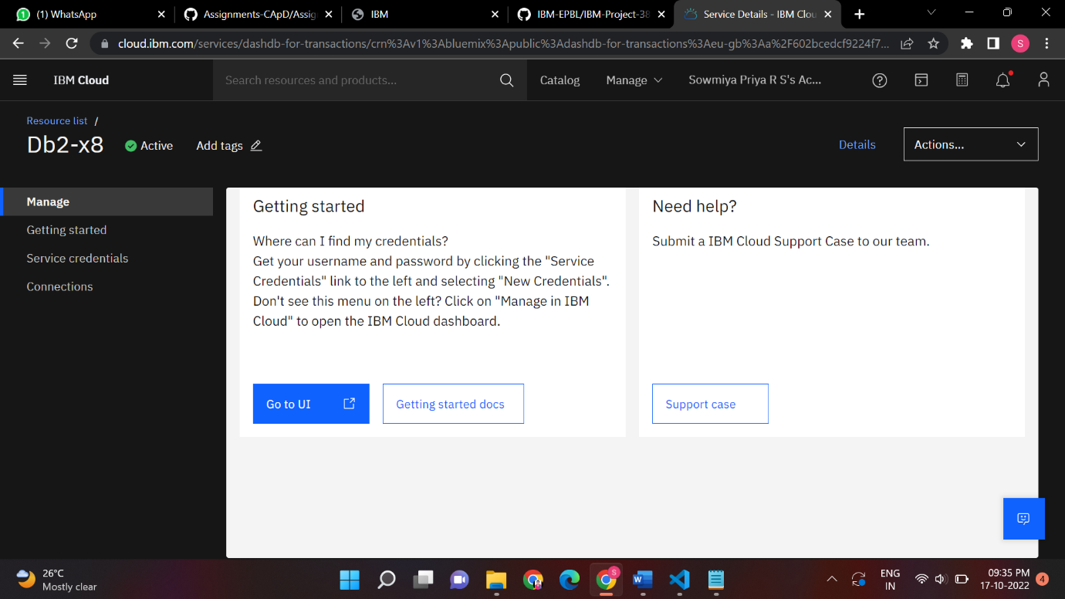

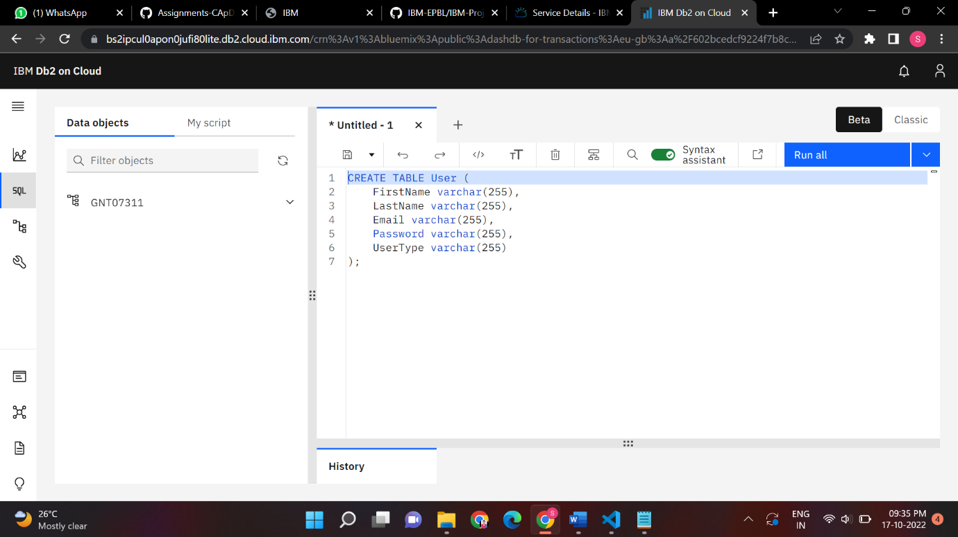

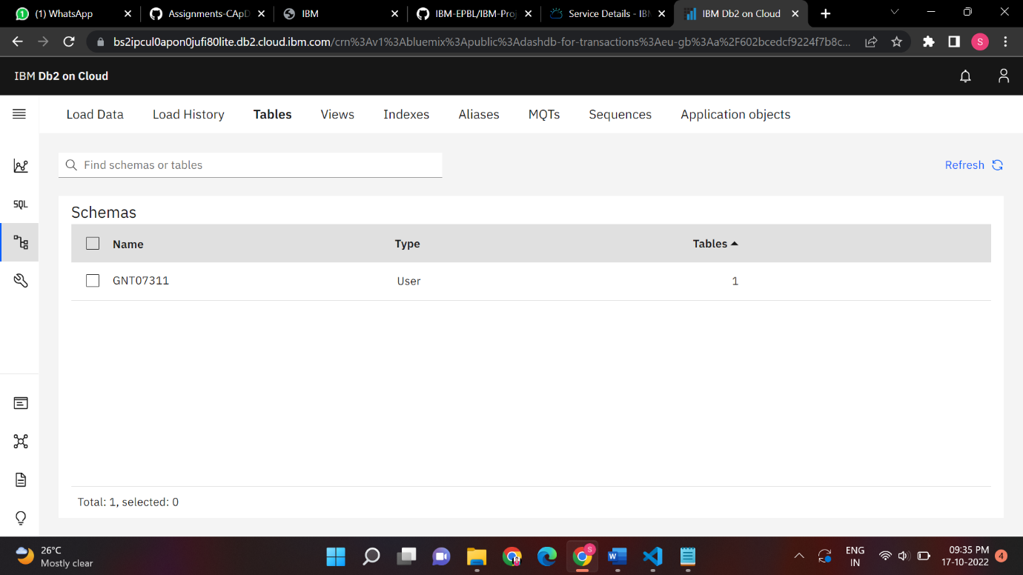

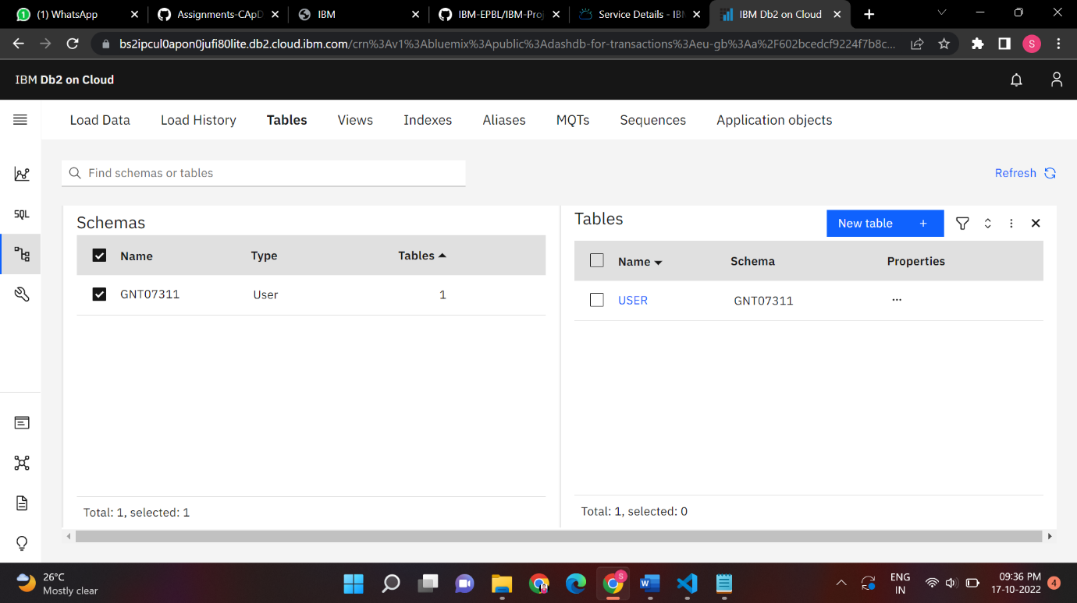

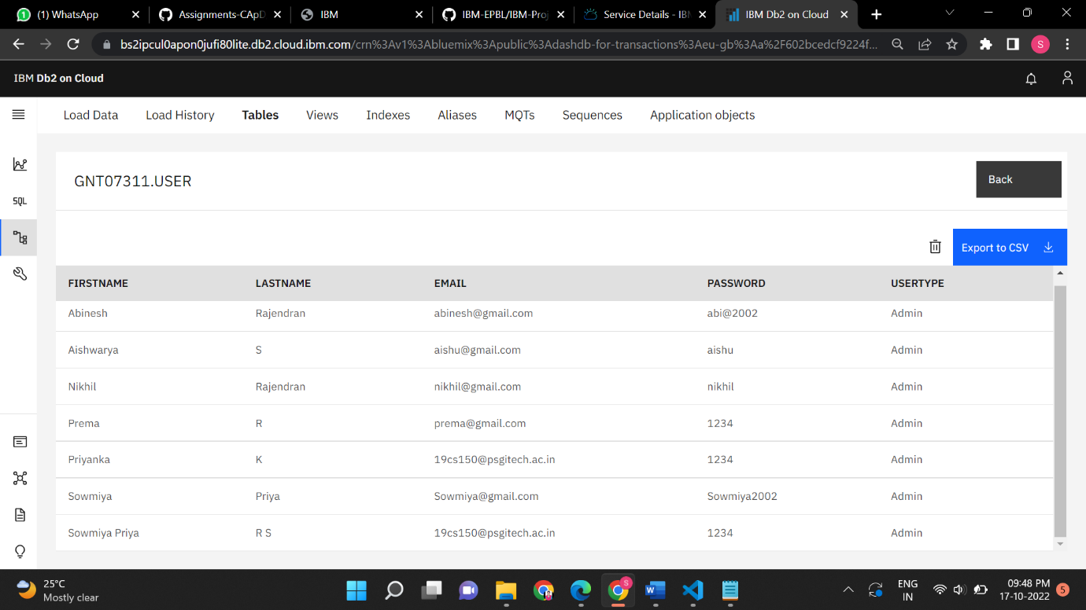

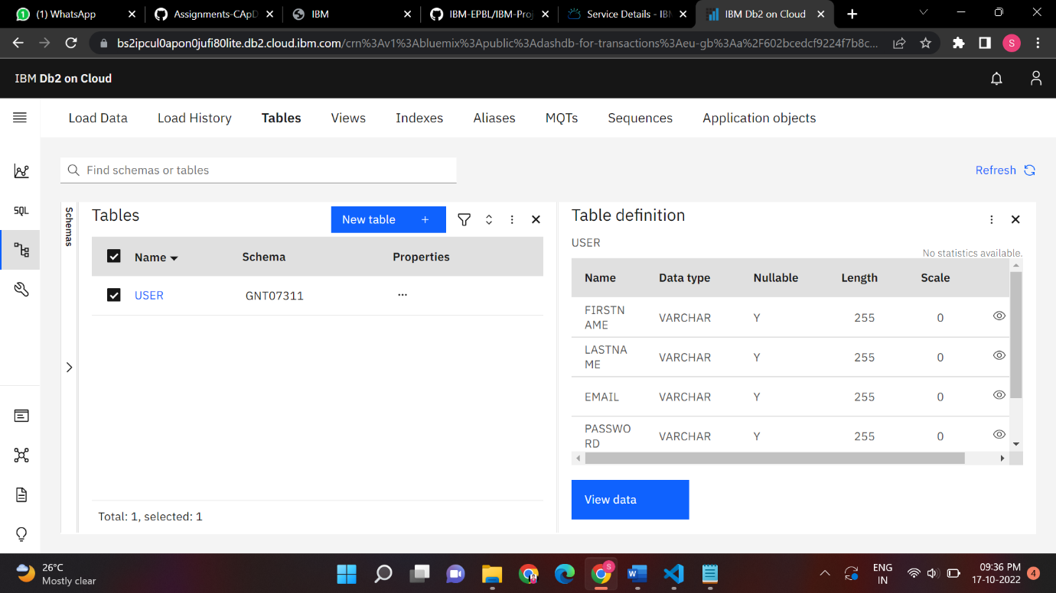

**SignUp:**

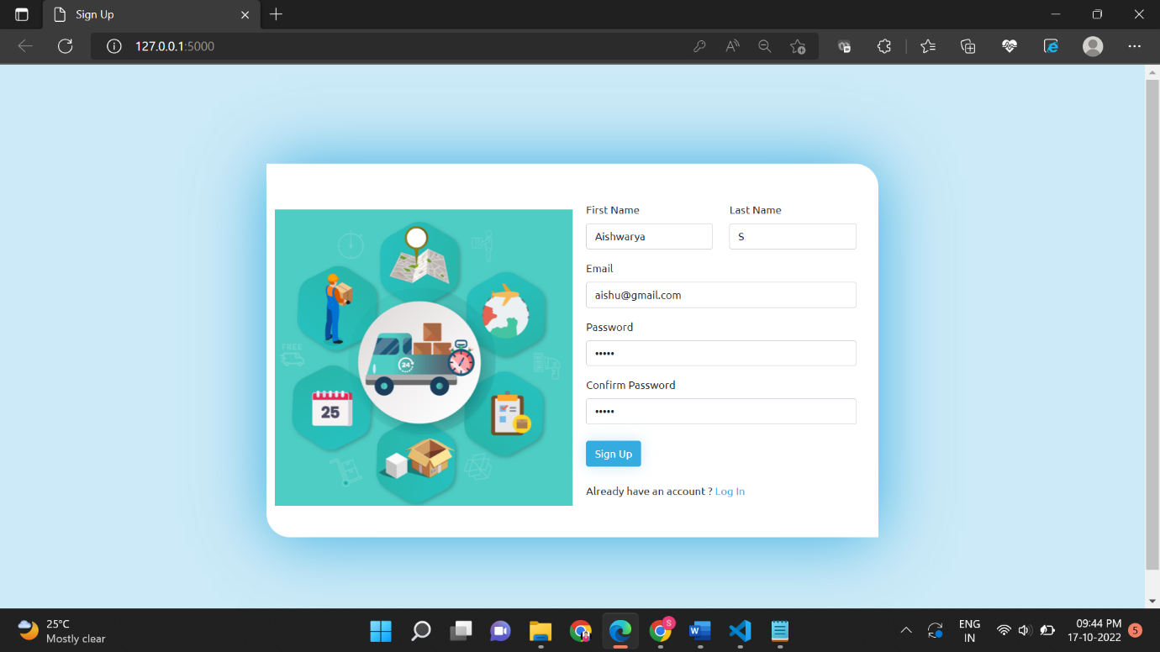

**Login**

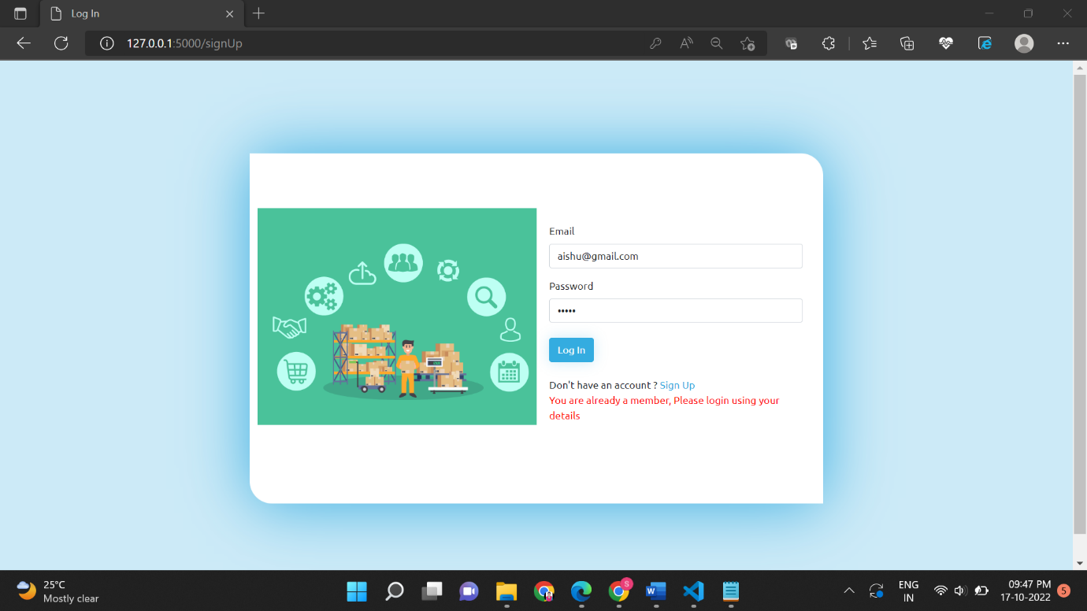

**Home:**

